|  |
| --- |
| > View(bank.full)  > sub_model = glm(formula = y~.,family = "binomial",data = bank.full)  > summary(sub_model)  Call:  glm(formula = y ~ ., family = "binomial", data = bank.full)  Deviance Residuals:  Min 1Q Median 3Q Max  -5.7286 -0.3744 -0.2530 -0.1502 3.4288  Coefficients:  Estimate Std. Error z value Pr(>|z|)  (Intercept) -2.536e+00 1.837e-01 -13.803 < 2e-16 ***  age 1.127e-04 2.205e-03 0.051 0.959233  jobblue-collar -3.099e-01 7.267e-02 -4.264 2.01e-05 ***  jobentrepreneur -3.571e-01 1.256e-01 -2.844 0.004455 **  jobhousemaid -5.040e-01 1.365e-01 -3.693 0.000221 ***  jobmanagement -1.653e-01 7.329e-02 -2.255 0.024130 *  jobretired 2.524e-01 9.722e-02 2.596 0.009436 **  jobself-employed -2.983e-01 1.120e-01 -2.664 0.007726 **  jobservices -2.238e-01 8.406e-02 -2.662 0.007763 **  jobstudent 3.821e-01 1.090e-01 3.505 0.000457 ***  jobtechnician -1.760e-01 6.893e-02 -2.554 0.010664 *  jobunemployed -1.767e-01 1.116e-01 -1.583 0.113456  jobunknown -3.133e-01 2.335e-01 -1.342 0.179656  maritalmarried -1.795e-01 5.891e-02 -3.046 0.002318 **  maritalsingle 9.250e-02 6.726e-02 1.375 0.169066  educationsecondary 1.835e-01 6.479e-02 2.833 0.004618 **  educationtertiary 3.789e-01 7.532e-02 5.031 4.88e-07 ***  educationunknown 2.505e-01 1.039e-01 2.411 0.015915 *  defaultyes -1.668e-02 1.628e-01 -0.102 0.918407  balance 1.283e-05 5.148e-06 2.493 0.012651 *  housingyes -6.754e-01 4.387e-02 -15.395 < 2e-16 ***  loanyes -4.254e-01 5.999e-02 -7.091 1.33e-12 ***  contacttelephone -1.634e-01 7.519e-02 -2.173 0.029784 *  contactunknown -1.623e+00 7.317e-02 -22.184 < 2e-16 ***  day 9.969e-03 2.497e-03 3.993 6.53e-05 ***  monthaug -6.939e-01 7.847e-02 -8.842 < 2e-16 ***  monthdec 6.911e-01 1.767e-01 3.912 9.17e-05 ***  monthfeb -1.473e-01 8.941e-02 -1.648 0.099427 .  monthjan -1.262e+00 1.217e-01 -10.367 < 2e-16 ***  monthjul -8.308e-01 7.740e-02 -10.733 < 2e-16 ***  monthjun 4.536e-01 9.367e-02 4.843 1.28e-06 ***  monthmar 1.590e+00 1.199e-01 13.265 < 2e-16 ***  monthmay -3.991e-01 7.229e-02 -5.521 3.36e-08 ***  monthnov -8.734e-01 8.441e-02 -10.347 < 2e-16 ***  monthoct 8.814e-01 1.080e-01 8.159 3.37e-16 ***  monthsep 8.741e-01 1.195e-01 7.314 2.58e-13 ***  duration 4.194e-03 6.453e-05 64.986 < 2e-16 ***  campaign -9.078e-02 1.014e-02 -8.955 < 2e-16 ***  pdays -1.027e-04 3.061e-04 -0.335 0.737268  previous 1.015e-02 6.503e-03 1.561 0.118476  poutcomeother 2.035e-01 8.986e-02 2.265 0.023543 *  poutcomesuccess 2.291e+00 8.235e-02 27.821 < 2e-16 ***  poutcomeunknown -9.179e-02 9.347e-02 -0.982 0.326093  ---  Signif. codes: 0 ‘***’ 0.001 ‘**’ 0.01 ‘*’ 0.05 ‘.’ 0.1 ‘ ’ 1  (Dispersion parameter for binomial family taken to be 1)  Null deviance: 32631 on 45210 degrees of freedom  Residual deviance: 21562 on 45168 degrees of freedom  AIC: 21648  Number of Fisher Scoring iterations: 6  > #as the model is not appropriate we can convert it  > plot(sub_model)  Hit <Return> to see next plot: |
|  |
| |  | | --- | | Hit <Return> to see next plot: | |

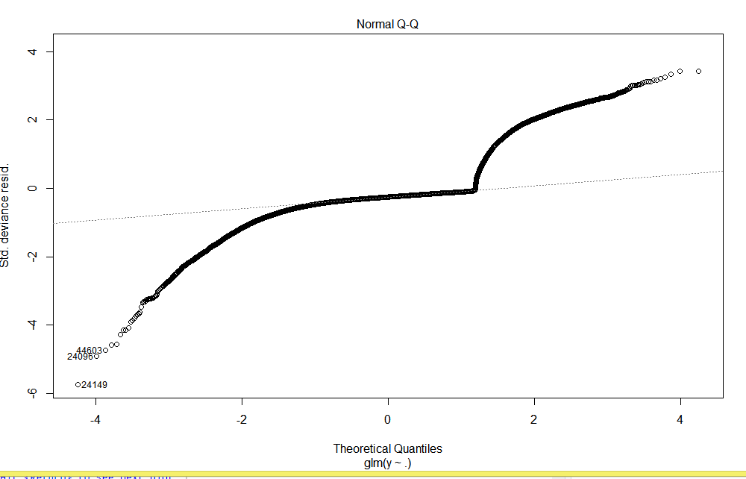

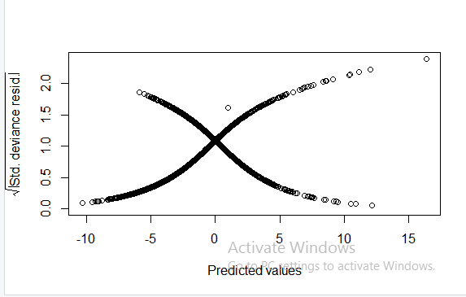

> plot(sub_model)

Hit <Return> to see next plot:

Hit <Return> to see next plot:

Hit <Return> to see next plot:

Hit <Return> to see next plot:

> library(car)

Loading required package: carData

> ?vif

> vif(sub_model)

GVIF Df GVIF^(1/(2*Df))

age 2.180880 1 1.476780

job 4.165825 11 1.067009

marital 1.444128 2 1.096229

education 2.257484 3 1.145348

default 1.016611 1 1.008271

balance 1.042409 1 1.020984

housing 1.428124 1 1.195041

loan 1.064119 1 1.031561

contact 1.902585 2 1.174454

day 1.343766 1 1.159209

month 3.744738 11 1.061854

duration 1.126210 1 1.061231

campaign 1.106459 1 1.051883

pdays 3.665840 1 1.914638

previous 1.278820 1 1.130849

poutcome 4.217021 3 1.271065

> influenceIndexPlot(sub_model)

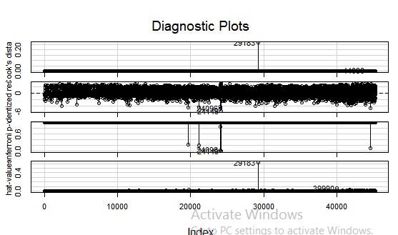

> gc()

used (Mb) gc trigger (Mb) max used (Mb)

Ncells 3086701 164.9 5142540 274.7 5142540 274.7

Vcells 11941713 91.2 22535068 172.0 22534967 172.0

> influencePlot(sub_model)

StudRes Hat CookD

24096 -4.918148 3.292541e-07 0.001330557

24149 -5.737221 7.383078e-09 0.002295567

29183 -2.622004 6.231848e-01 0.265983467

39990 -1.105389 6.644712e-02 0.001402566

44090 2.225898 1.250629e-02 0.003032282

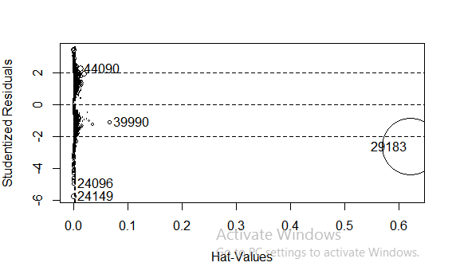

> bank_new= bank.full[-c(24096,24149,29183,39990,44040),]

> sub_model1 = glm(formula = bank_new$y~., family = "binomial", data = bank_new)

> summary(sub_model1)

Call:

glm(formula = bank_new$y ~ ., family = "binomial", data = bank_new)

Deviance Residuals:

Min 1Q Median 3Q Max

-4.7507 -0.3736 -0.2517 -0.1490 3.4442

Coefficients:

Estimate Std. Error z value Pr(>|z|)

(Intercept) -2.614e+00 1.857e-01 -14.081 < 2e-16 ***

age 4.199e-05 2.208e-03 0.019 0.984830

jobblue-collar -3.120e-01 7.278e-02 -4.287 1.81e-05 ***

jobentrepreneur -3.607e-01 1.258e-01 -2.868 0.004132 **

jobhousemaid -5.059e-01 1.367e-01 -3.701 0.000214 ***

jobmanagement -1.690e-01 7.338e-02 -2.303 0.021297 *

jobretired 2.502e-01 9.737e-02 2.570 0.010169 *

jobself-employed -3.041e-01 1.122e-01 -2.711 0.006700 **

jobservices -2.251e-01 8.420e-02 -2.673 0.007512 **

jobstudent 3.782e-01 1.093e-01 3.461 0.000538 ***

jobtechnician -1.775e-01 6.900e-02 -2.573 0.010083 *

jobunemployed -1.814e-01 1.118e-01 -1.623 0.104646

jobunknown -3.184e-01 2.338e-01 -1.362 0.173291

maritalmarried -1.788e-01 5.900e-02 -3.031 0.002437 **

maritalsingle 9.139e-02 6.737e-02 1.357 0.174917

educationsecondary 1.868e-01 6.491e-02 2.878 0.004007 **

educationtertiary 3.840e-01 7.546e-02 5.089 3.60e-07 ***

educationunknown 2.543e-01 1.041e-01 2.443 0.014549 *

defaultyes -1.432e-02 1.630e-01 -0.088 0.929980

balance 1.406e-05 5.297e-06 2.653 0.007972 **

housingyes -6.777e-01 4.394e-02 -15.423 < 2e-16 ***

loanyes -4.285e-01 6.011e-02 -7.129 1.01e-12 ***

contacttelephone -1.565e-01 7.517e-02 -2.082 0.037326 *

contactunknown -1.628e+00 7.332e-02 -22.204 < 2e-16 ***

day 1.011e-02 2.501e-03 4.041 5.32e-05 ***

monthaug -6.951e-01 7.859e-02 -8.846 < 2e-16 ***

monthdec 6.883e-01 1.769e-01 3.890 0.000100 ***

monthfeb -1.427e-01 8.951e-02 -1.594 0.110892

monthjan -1.267e+00 1.218e-01 -10.402 < 2e-16 ***

monthjul -8.348e-01 7.753e-02 -10.768 < 2e-16 ***

monthjun 4.551e-01 9.385e-02 4.849 1.24e-06 ***

monthmar 1.592e+00 1.200e-01 13.273 < 2e-16 ***

monthmay -4.016e-01 7.241e-02 -5.546 2.92e-08 ***

monthnov -8.730e-01 8.450e-02 -10.332 < 2e-16 ***

monthoct 8.863e-01 1.081e-01 8.201 2.39e-16 ***

monthsep 8.724e-01 1.196e-01 7.293 3.04e-13 ***

duration 4.226e-03 6.481e-05 65.203 < 2e-16 ***

campaign -9.242e-02 1.019e-02 -9.072 < 2e-16 ***

pdays -6.432e-05 3.061e-04 -0.210 0.833556

previous 3.040e-02 9.807e-03 3.099 0.001939 **

poutcomeother 1.906e-01 9.012e-02 2.115 0.034425 *

poutcomesuccess 2.295e+00 8.248e-02 27.830 < 2e-16 ***

poutcomeunknown -2.119e-02 9.687e-02 -0.219 0.826810

---

Signif. codes: 0 ‘***’ 0.001 ‘**’ 0.01 ‘*’ 0.05 ‘.’ 0.1 ‘ ’ 1

(Dispersion parameter for binomial family taken to be 1)

Null deviance: 32626 on 45205 degrees of freedom

Residual deviance: 21497 on 45163 degrees of freedom

AIC: 21583

Number of Fisher Scoring iterations: 6

> vif(sub_model1)

GVIF Df GVIF^(1/(2*Df))

age 2.181308 1 1.476925

job 4.167652 11 1.067031

marital 1.444113 2 1.096226

education 2.258128 3 1.145402

default 1.016761 1 1.008346

balance 1.043639 1 1.021586

housing 1.428471 1 1.195187

loan 1.064401 1 1.031698

contact 1.903648 2 1.174618

day 1.344386 1 1.159477

month 3.748428 11 1.061901

duration 1.128493 1 1.062306

campaign 1.107835 1 1.052537

pdays 3.659022 1 1.912857

previous 1.637577 1 1.279678

poutcome 4.662148 3 1.292501

> pred1 = Predict(sub_model, data = bank.full, type = "response")

> confusion = table(pred1>0.5, bank.full$y)

> confusion

no yes

FALSE 38940 3456

TRUE 982 1833

> accuracy= sum(diag(confusion))/sum(confusion)

> accuracy

[1] 0.901838

> library(ROCR)

> ROCACC= prediction(pred1,bank.full$y)

> ?performance

> ROCPERF = performance(ROCACC,'tpr','fpr')

> plot(ROCPERF)

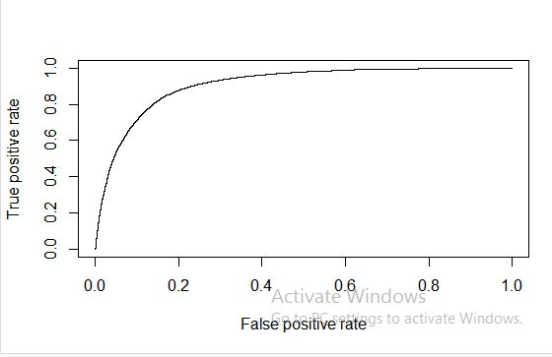

> str(ROCPERF)

Formal class 'performance' [package "ROCR"] with 6 slots

..@ x.name : chr "False positive rate"

..@ y.name : chr "True positive rate"

..@ alpha.name : chr "Cutoff"

..@ x.values :List of 1

.. ..$ : num [1:45212] 0.00 2.50e-05 2.50e-05 5.01e-05 7.51e-05 ...

..@ y.values :List of 1

.. ..$ : num [1:45212] 0 0 0.000189 0.000189 0.000189 ...

..@ alpha.values:List of 1

.. ..$ : num [1:45212] Inf 1 1 1 1 ...

> rocr_cutoff= data.frame(cut_off=ROCPERF@alpha.values[[1]],fpr=ROCPERF@x.values,tpr=ROCPERF@y.values)

> colnames(rocr_cutoff)= c("cut_off","fpr","tpr")

> rocr_cutoff

cut_off fpr tpr

1 Inf 0.000000e+00 0.0000000000

2 0.9999999 2.504885e-05 0.0000000000

3 0.9999948 2.504885e-05 0.0001890717

4 0.9999942 5.009769e-05 0.0001890717

5 0.9999860 7.514654e-05 0.0001890717

6 0.9999813 7.514654e-05 0.0003781433

7 0.9999725 7.514654e-05 0.0005672150

8 0.9999719 1.001954e-04 0.0005672150

9 0.9999693 1.252442e-04 0.0005672150

10 0.9999239 1.252442e-04 0.0007562866

11 0.9999145 1.252442e-04 0.0009453583

12 0.9999014 1.252442e-04 0.0011344299

13 0.9998919 1.502931e-04 0.0011344299

14 0.9998197 1.753419e-04 0.0011344299

15 0.9998093 2.003908e-04 0.0011344299

16 0.9998076 2.003908e-04 0.0013235016

17 0.9997849 2.003908e-04 0.0015125733

18 0.9997633 2.254396e-04 0.0015125733

19 0.9995512 2.254396e-04 0.0017016449

20 0.9995027 2.504885e-04 0.0017016449

21 0.9994660 2.504885e-04 0.0018907166

22 0.9994458 2.504885e-04 0.0020797882

23 0.9994151 2.755373e-04 0.0020797882

24 0.9993996 2.755373e-04 0.0022688599

25 0.9993098 2.755373e-04 0.0024579316

26 0.9992353 2.755373e-04 0.0026470032

27 0.9992329 3.005861e-04 0.0026470032

28 0.9990393 3.005861e-04 0.0028360749

29 0.9990193 3.256350e-04 0.0028360749

30 0.9988566 3.506838e-04 0.0028360749

31 0.9987796 3.757327e-04 0.0028360749

32 0.9985457 4.007815e-04 0.0028360749

33 0.9982477 4.007815e-04 0.0030251465

34 0.9980338 4.007815e-04 0.0032142182

35 0.9976745 4.007815e-04 0.0034032898

36 0.9976270 4.007815e-04 0.0035923615

37 0.9975584 4.007815e-04 0.0037814332

38 0.9975578 4.007815e-04 0.0039705048

39 0.9975494 4.258304e-04 0.0039705048

40 0.9973989 4.258304e-04 0.0041595765

41 0.9970574 4.258304e-04 0.0043486481

42 0.9969701 4.258304e-04 0.0045377198

43 0.9968193 4.258304e-04 0.0047267915

44 0.9966565 4.258304e-04 0.0049158631

45 0.9966105 4.258304e-04 0.0051049348

46 0.9965374 4.258304e-04 0.0052940064

47 0.9963311 4.258304e-04 0.0054830781

48 0.9963290 4.258304e-04 0.0056721497

49 0.9960829 4.508792e-04 0.0056721497

50 0.9959449 4.508792e-04 0.0058612214

51 0.9958585 4.759281e-04 0.0058612214

52 0.9958068 5.009769e-04 0.0058612214

53 0.9956346 5.009769e-04 0.0060502931

54 0.9955243 5.009769e-04 0.0062393647

55 0.9954633 5.260258e-04 0.0062393647

56 0.9954249 5.260258e-04 0.0064284364

57 0.9953803 5.260258e-04 0.0066175080

58 0.9952974 5.260258e-04 0.0068065797

59 0.9952551 5.260258e-04 0.0069956514

60 0.9949902 5.510746e-04 0.0069956514

61 0.9949692 5.761234e-04 0.0069956514

62 0.9946244 6.011723e-04 0.0069956514

63 0.9945574 6.262211e-04 0.0069956514

64 0.9945307 6.512700e-04 0.0069956514

65 0.9944828 6.763188e-04 0.0069956514

66 0.9942290 7.013677e-04 0.0069956514

67 0.9941776 7.264165e-04 0.0069956514

68 0.9940730 7.514654e-04 0.0069956514

69 0.9939895 7.514654e-04 0.0071847230

70 0.9936566 7.765142e-04 0.0071847230

71 0.9933087 8.015630e-04 0.0071847230

72 0.9929723 8.266119e-04 0.0071847230

73 0.9927668 8.516607e-04 0.0071847230

74 0.9925404 8.516607e-04 0.0073737947

75 0.9923254 8.516607e-04 0.0075628663

76 0.9921880 8.516607e-04 0.0077519380

77 0.9920389 8.767096e-04 0.0077519380

78 0.9919334 9.017584e-04 0.0077519380

79 0.9912532 9.017584e-04 0.0079410096

80 0.9911825 9.017584e-04 0.0081300813

81 0.9910097 9.017584e-04 0.0083191530

82 0.9907715 9.017584e-04 0.0085082246

83 0.9907166 9.017584e-04 0.0086972963

84 0.9901420 9.017584e-04 0.0088863679

85 0.9897338 9.017584e-04 0.0090754396

86 0.9895296 9.017584e-04 0.0092645112

87 0.9892642 9.017584e-04 0.0094535829

88 0.9892206 9.268073e-04 0.0094535829

89 0.9890006 9.268073e-04 0.0096426546

90 0.9889653 9.268073e-04 0.0098317262

91 0.9888757 9.268073e-04 0.0100207979

92 0.9888662 9.268073e-04 0.0102098695

93 0.9886208 9.268073e-04 0.0103989412

94 0.9885585 9.518561e-04 0.0103989412

95 0.9884151 9.518561e-04 0.0105880129

96 0.9881416 9.518561e-04 0.0107770845

97 0.9880361 9.518561e-04 0.0109661562

98 0.9880081 9.518561e-04 0.0111552278

99 0.9877949 9.769050e-04 0.0111552278

100 0.9877104 1.001954e-03 0.0111552278

101 0.9876459 1.001954e-03 0.0113442995

102 0.9876006 1.001954e-03 0.0115333711

103 0.9873478 1.001954e-03 0.0117224428

104 0.9869791 1.001954e-03 0.0119115145

105 0.9869383 1.001954e-03 0.0121005861

106 0.9867615 1.027003e-03 0.0121005861

107 0.9867509 1.027003e-03 0.0122896578

108 0.9865188 1.052052e-03 0.0122896578

109 0.9860416 1.052052e-03 0.0124787294

110 0.9858249 1.052052e-03 0.0126678011

111 0.9855838 1.077100e-03 0.0126678011

112 0.9853884 1.077100e-03 0.0128568728

113 0.9852475 1.077100e-03 0.0130459444

114 0.9851113 1.102149e-03 0.0130459444

115 0.9850014 1.102149e-03 0.0132350161

116 0.9849681 1.102149e-03 0.0134240877

117 0.9849376 1.102149e-03 0.0136131594

118 0.9845310 1.127198e-03 0.0136131594

119 0.9843225 1.127198e-03 0.0138022310

120 0.9841413 1.127198e-03 0.0139913027

121 0.9839840 1.127198e-03 0.0141803744

122 0.9837846 1.127198e-03 0.0143694460

123 0.9837203 1.127198e-03 0.0145585177

124 0.9837184 1.127198e-03 0.0147475893

125 0.9836954 1.127198e-03 0.0149366610

126 0.9836302 1.127198e-03 0.0151257327

127 0.9835778 1.152247e-03 0.0151257327

128 0.9835613 1.152247e-03 0.0153148043

129 0.9833440 1.152247e-03 0.0155038760

130 0.9832614 1.177296e-03 0.0155038760

131 0.9832015 1.202345e-03 0.0155038760

132 0.9831247 1.202345e-03 0.0156929476

133 0.9830637 1.227393e-03 0.0156929476

134 0.9827863 1.227393e-03 0.0158820193

135 0.9827179 1.227393e-03 0.0160710909

136 0.9823800 1.227393e-03 0.0162601626

137 0.9819162 1.227393e-03 0.0164492343

138 0.9818759 1.227393e-03 0.0166383059

139 0.9811956 1.252442e-03 0.0166383059

140 0.9811518 1.252442e-03 0.0168273776

141 0.9808961 1.277491e-03 0.0168273776

142 0.9808279 1.277491e-03 0.0170164492

143 0.9807974 1.277491e-03 0.0172055209

144 0.9806770 1.277491e-03 0.0173945926

145 0.9806299 1.277491e-03 0.0175836642

146 0.9804264 1.277491e-03 0.0177727359

147 0.9800757 1.277491e-03 0.0179618075

148 0.9798481 1.302540e-03 0.0179618075

149 0.9797954 1.327589e-03 0.0179618075

150 0.9797248 1.327589e-03 0.0181508792

151 0.9790173 1.327589e-03 0.0183399508

152 0.9790037 1.327589e-03 0.0185290225

153 0.9789361 1.327589e-03 0.0187180942

154 0.9788548 1.352638e-03 0.0187180942

155 0.9778085 1.352638e-03 0.0189071658

156 0.9770710 1.377686e-03 0.0189071658

157 0.9768801 1.402735e-03 0.0189071658

158 0.9768281 1.427784e-03 0.0189071658

159 0.9764153 1.427784e-03 0.0190962375

160 0.9763636 1.427784e-03 0.0192853091

161 0.9758793 1.452833e-03 0.0192853091

162 0.9758351 1.477882e-03 0.0192853091

163 0.9756801 1.477882e-03 0.0194743808

164 0.9756067 1.502931e-03 0.0194743808

165 0.9753425 1.527980e-03 0.0194743808

166 0.9752711 1.527980e-03 0.0196634524

167 0.9752374 1.527980e-03 0.0198525241

168 0.9750870 1.553028e-03 0.0198525241

169 0.9745105 1.553028e-03 0.0200415958

170 0.9744488 1.553028e-03 0.0202306674

171 0.9744385 1.553028e-03 0.0204197391

172 0.9742108 1.553028e-03 0.0206088107

173 0.9740262 1.553028e-03 0.0207978824

174 0.9738666 1.553028e-03 0.0209869541

175 0.9732674 1.553028e-03 0.0211760257

176 0.9732449 1.578077e-03 0.0211760257

177 0.9731034 1.578077e-03 0.0213650974

178 0.9725272 1.603126e-03 0.0213650974

179 0.9725210 1.603126e-03 0.0215541690

180 0.9721985 1.628175e-03 0.0215541690

181 0.9721468 1.628175e-03 0.0217432407

182 0.9720469 1.628175e-03 0.0219323123

183 0.9711474 1.628175e-03 0.0221213840

184 0.9710447 1.628175e-03 0.0223104557

185 0.9709966 1.628175e-03 0.0224995273

186 0.9708242 1.628175e-03 0.0226885990

187 0.9708162 1.653224e-03 0.0226885990

188 0.9705147 1.653224e-03 0.0228776706

189 0.9702758 1.678273e-03 0.0228776706

190 0.9697473 1.678273e-03 0.0230667423

191 0.9694585 1.678273e-03 0.0232558140

192 0.9693559 1.678273e-03 0.0234448856

193 0.9691216 1.678273e-03 0.0236339573

194 0.9684868 1.703321e-03 0.0236339573

195 0.9684862 1.728370e-03 0.0236339573

196 0.9683695 1.728370e-03 0.0238230289

197 0.9680509 1.753419e-03 0.0238230289

198 0.9678953 1.778468e-03 0.0238230289

199 0.9674457 1.778468e-03 0.0240121006

200 0.9670420 1.778468e-03 0.0242011722

201 0.9667685 1.778468e-03 0.0243902439

202 0.9663554 1.778468e-03 0.0245793156

203 0.9656143 1.778468e-03 0.0247683872

204 0.9654591 1.778468e-03 0.0249574589

205 0.9654478 1.778468e-03 0.0251465305

206 0.9650886 1.778468e-03 0.0253356022

207 0.9649627 1.778468e-03 0.0255246739

208 0.9648204 1.778468e-03 0.0257137455

209 0.9647554 1.778468e-03 0.0259028172

210 0.9645769 1.778468e-03 0.0260918888

211 0.9643283 1.803517e-03 0.0260918888

212 0.9642831 1.828566e-03 0.0260918888

213 0.9642351 1.828566e-03 0.0262809605

214 0.9640445 1.853615e-03 0.0262809605

215 0.9637330 1.853615e-03 0.0264700321

216 0.9636482 1.878663e-03 0.0264700321

217 0.9625377 1.878663e-03 0.0266591038

218 0.9612646 1.903712e-03 0.0266591038

219 0.9609132 1.903712e-03 0.0268481755

220 0.9608463 1.903712e-03 0.0270372471

221 0.9607767 1.928761e-03 0.0270372471

222 0.9605288 1.928761e-03 0.0272263188

223 0.9604897 1.928761e-03 0.0274153904

224 0.9600975 1.928761e-03 0.0276044621

225 0.9587846 1.953810e-03 0.0276044621

226 0.9586733 1.953810e-03 0.0277935337

227 0.9580987 1.953810e-03 0.0279826054

228 0.9580471 1.953810e-03 0.0281716771

229 0.9579748 1.978859e-03 0.0281716771

230 0.9578950 2.003908e-03 0.0281716771

231 0.9578165 2.003908e-03 0.0283607487

232 0.9577936 2.003908e-03 0.0285498204

233 0.9576473 2.003908e-03 0.0287388920

234 0.9574192 2.028956e-03 0.0287388920

235 0.9572471 2.028956e-03 0.0289279637

236 0.9569793 2.054005e-03 0.0289279637

237 0.9568606 2.054005e-03 0.0291170354

238 0.9568405 2.054005e-03 0.0293061070

239 0.9565940 2.054005e-03 0.0294951787

240 0.9565743 2.079054e-03 0.0294951787

241 0.9560660 2.104103e-03 0.0294951787

242 0.9556301 2.104103e-03 0.0296842503

243 0.9555981 2.104103e-03 0.0298733220

244 0.9555216 2.104103e-03 0.0300623936

245 0.9553308 2.104103e-03 0.0302514653

246 0.9553301 2.129152e-03 0.0302514653

247 0.9552939 2.129152e-03 0.0304405370

248 0.9551178 2.129152e-03 0.0306296086

249 0.9550754 2.129152e-03 0.0308186803

250 0.9547795 2.129152e-03 0.0310077519

251 0.9545277 2.129152e-03 0.0311968236

252 0.9542433 2.154201e-03 0.0311968236

253 0.9536129 2.179250e-03 0.0311968236

254 0.9533007 2.179250e-03 0.0313858953

255 0.9532955 2.179250e-03 0.0315749669

256 0.9532182 2.179250e-03 0.0317640386

257 0.9529346 2.179250e-03 0.0319531102

258 0.9528330 2.179250e-03 0.0321421819

259 0.9527922 2.179250e-03 0.0323312535

260 0.9527718 2.179250e-03 0.0325203252

261 0.9524652 2.179250e-03 0.0327093969

262 0.9524327 2.179250e-03 0.0328984685

263 0.9523983 2.179250e-03 0.0330875402

264 0.9522146 2.179250e-03 0.0332766118

265 0.9521477 2.179250e-03 0.0334656835

266 0.9521129 2.179250e-03 0.0336547552

267 0.9518128 2.179250e-03 0.0338438268

268 0.9517164 2.204298e-03 0.0338438268

269 0.9514362 2.204298e-03 0.0340328985

270 0.9512235 2.204298e-03 0.0342219701

271 0.9509985 2.204298e-03 0.0344110418

272 0.9509945 2.204298e-03 0.0346001134

273 0.9508103 2.204298e-03 0.0347891851

274 0.9503562 2.204298e-03 0.0349782568

275 0.9503090 2.204298e-03 0.0351673284

276 0.9503021 2.204298e-03 0.0353564001

277 0.9502406 2.204298e-03 0.0355454717

278 0.9501022 2.204298e-03 0.0357345434

279 0.9497451 2.204298e-03 0.0359236151

280 0.9495376 2.204298e-03 0.0361126867

281 0.9492670 2.229347e-03 0.0361126867

282 0.9487824 2.229347e-03 0.0363017584

283 0.9487574 2.229347e-03 0.0364908300

284 0.9482478 2.229347e-03 0.0366799017

285 0.9479695 2.254396e-03 0.0366799017

286 0.9477725 2.254396e-03 0.0368689733

287 0.9477670 2.254396e-03 0.0370580450

288 0.9474798 2.254396e-03 0.0372471167

289 0.9472790 2.279445e-03 0.0372471167

290 0.9468735 2.304494e-03 0.0372471167

291 0.9466133 2.304494e-03 0.0374361883

292 0.9464339 2.329543e-03 0.0374361883

293 0.9464165 2.354591e-03 0.0374361883

294 0.9461341 2.379640e-03 0.0374361883

295 0.9460144 2.379640e-03 0.0376252600

296 0.9459506 2.379640e-03 0.0378143316

297 0.9456866 2.379640e-03 0.0380034033

298 0.9456638 2.404689e-03 0.0380034033

299 0.9456583 2.404689e-03 0.0381924749

300 0.9455099 2.404689e-03 0.0383815466

301 0.9448064 2.429738e-03 0.0383815466

302 0.9447701 2.429738e-03 0.0385706183

303 0.9445510 2.429738e-03 0.0387596899

304 0.9444354 2.429738e-03 0.0389487616

305 0.9440737 2.429738e-03 0.0391378332

306 0.9438387 2.454787e-03 0.0391378332

307 0.9435113 2.454787e-03 0.0393269049

308 0.9434661 2.454787e-03 0.0395159766

309 0.9429783 2.454787e-03 0.0397050482

310 0.9429709 2.454787e-03 0.0398941199

311 0.9428102 2.454787e-03 0.0400831915

312 0.9427350 2.454787e-03 0.0402722632

313 0.9423146 2.479836e-03 0.0402722632

314 0.9422364 2.479836e-03 0.0404613348

315 0.9421018 2.479836e-03 0.0406504065

316 0.9417499 2.479836e-03 0.0408394782

317 0.9416213 2.504885e-03 0.0408394782

318 0.9414535 2.504885e-03 0.0410285498

319 0.9414046 2.504885e-03 0.0412176215

320 0.9410667 2.504885e-03 0.0414066931

321 0.9409276 2.504885e-03 0.0415957648

322 0.9407578 2.529933e-03 0.0415957648

323 0.9406013 2.529933e-03 0.0417848365

324 0.9402608 2.529933e-03 0.0419739081

325 0.9398022 2.529933e-03 0.0421629798

326 0.9395789 2.554982e-03 0.0421629798

327 0.9392537 2.580031e-03 0.0421629798

328 0.9392431 2.580031e-03 0.0423520514

329 0.9391371 2.580031e-03 0.0425411231

330 0.9379294 2.580031e-03 0.0427301947

331 0.9378153 2.580031e-03 0.0429192664

332 0.9377978 2.580031e-03 0.0431083381

333 0.9377180 2.580031e-03 0.0432974097

[ reached 'max' / getOption("max.print") -- omitted 44879 rows ]